Forest Conservation
Application #___________
Municipality____________
Date Received__________
FOR OFFICE USE ONLY
Due Diligence
Grant Program

COVER PAGE

Complete Part 1 of this application and return the original signed application with all requested documentation to Mount Grace Land Conservation Trust, the grant administrator:

Mount Grace Land Conservation Trust
Due Diligence Grant Program
1461 Old Keene Road
Athol, MA 01331

Important notes about the Forest Conservation Due Diligence Grant process:

- This application must be filled out for all applicants seeking a Grant before the deed or the conservation restriction is recorded, and before due diligence costs are expended. Property that has already been conserved and recorded without first receiving Part 1 and Part 2 Approval Letters will not be eligible for a Grant. Maximum Grant award is $8,700.

- To see if you qualify, first complete and submit Part 1 of this application to Mount Grace. You will then receive a Part 1 Approval Letter if you are qualified to proceed further in the application process. Please do not submit Parts 2 and 3 of this application until you are notified with a Part 1 Approval Letter that your conservation project is eligible for a Grant.

- The Part 1 Approval Letter authorizes you to complete and submit Part 2 of the application, which includes some expenditures of eligible due diligence costs. The Part 2 process must be completed and required information submitted to Mount Grace within 90 days of Part 1 approval.

- Upon receipt of your Part 2 information, you will receive a Part 2 Approval Letter if you are eligible to proceed to Part 3, which includes additional expenditures of eligible due diligence costs and the recording of the conservation project. Documentation of the recording, along with final receipts of eligible due diligence closing costs, must be provided back to Mount Grace within 60 days of Part 2 approval.

- Once Mount Grace receives the recorded documents and the receipts of pre-approved due diligence costs, the applicant will receive reimbursement within 45 days.

Program Summary

The lack of funding for due diligence costs can be a barrier for landowners interested in conserving their woodlands. The Forest Conservation Due Diligence Grant Program provides financial assistance to qualified forest landowners who permanently protect their land, and who donate land or conservation restriction (CR) value. This Massachusetts Department of Conservation and Recreation (MA DCR) Program covers the costs of appraisals, title exams, surveys, closing costs, and environmental site assessments.¹

To be eligible for the Due Diligence Grant Program, landowners must:

- Own subject land in specific Massachusetts municipalities designated by the New England Governors’ Conference “Keeping Forests as Forests” report. These areas include the Massachusetts sections of the Taconics Partnership, Massachusetts-Vermont Woodland Partnership, Southern New England Heritage Forest Partnership, and Quabbin to Cardigan Partnership. ²

- Attend a qualified MA DCR Working Forest Initiative event or a qualified US Forest Service (USFS) New England Governors’ Conference Commission on Land Conservation Pilot Region event.

- Conserve at least 10 acres of forested land. In addition, MA DCR must determine that the land contains significant natural resource value.

- Donate all or part of the appraised value of the land or conservation restriction. The appraised value must be determined by a Qualified Independent Appraiser. The donation must be worth at least 50% of the conservation project’s appraised value or at least $100,000. Projects where 50% of appraised value is greater than $100,000 are only required to donate $100,000 of value to qualify.
  - For example, a project with a CR value of $350,000 would qualify if at least $100,000 is donated – which is less than 50% of its appraised value. In another example, a project with a CR value of $150,000 would qualify if $75,000 of the value is donated, which is 50% of the appraised value.

- Be enrolled in the Forest Stewardship Program or Chapter 61 (or Chapter 61A or Chapter 61B if the requirements of Chapter 61 are met). Landowners pursuing a CR who are not enrolled may apply for a Due Diligence Grant and enroll in the Forest Stewardship Program concurrently.

- The Due Diligence Grant may not exceed 50% of the donated value of the land or CR.
  - For example, a land donation of $10,000 is eligible for a grant worth no more than $5,000.

The program reimburses landowners for approved due diligence costs only after the project has been approved by MA DCR for eligibility and the project has been recorded at the Registry of Deeds.

The MA DCR Forest Conservation Due Diligence Grant Program is administered by Mount Grace Land Conservation Trust. For more information, contact Jay Rasku at 978-248-2118 or rasku@mountgrace.org. For information about other landowner incentive programs in the MA DCR Working Forest Initiative, go to www.masswoods.net.

¹Costs for these due diligence expenses are capped.
²A maximum of not more than two landowners per year may be eligible from the Quabbin to Cardigan region.

PART 1 APPLICATION
DUE DILIGENCE GRANT PRE-CERTIFICATION

REQUIRED FOR ELIGIBILITY:

- Does the proposed project include the permanent conservation of at least 10 acres of forested land? __YES __NO

- Does the property have a current Forest Stewardship Plan, or is the property currently enrolled in Chapter 61? The property may also be enrolled in Chapter 61A or Chapter 61B if the requirements of Chapter 61 are met. __YES __NO

- If the property does not have a current Forest Stewardship Plan or is not currently enrolled in Chapter 61, will a Forest Stewardship Plan be pursued concurrently with this application if the proposed project involves a conservation restriction (CR)? __YES __NO
Please explain:___________________________________________________________
_______________________________________________________________________

- Is the property located within a focus area as shown in Exhibit A or B of this application? __YES __NO

- Has the landowner attended a MA DCR Working Forest Initiative event or a US Forest Service (USFS) New England Governors’ Conference Commission on Land Conservation Pilot Region event? Please provide date, location, hosting organization and subject of the event:__________________________________________________________________
_______________________________________________________________________

Landowner Information
List all additional owners on a separate sheet if more than one owner address.
Landowner(s)_________________________________________________________________
Mailing Address________________________________________________________________
City/ Town____________________________________ State______________ Zip__________
Phone #_________________________________ Fax #________________________________
Email________________________________________________________________________

Type of Ownership
__Joint Tenancy __Tenants by the Entirety __Tenants in Common
__Life Estate __Other (describe)__________________________________________________

Type of Entity
__Individual(s) __Sole Proprietor __Trust __Estate __LLC __Partnership
__Limited Partnership __Limited Liability Partnership __Subchapter S Corporation
__Corporation (describe)_________________________________________________________
__Other Pass-Through Entity (describe)_____________________________________________

__Check here if you’ve added an additional sheet of owners.

Deed or Conservation Restriction Gift/ Bargain Sale

__Attach a copy of proposed deed with quitclaim covenants.
The recipient must be qualified under 501(c)(3) of the Internal Revenue Code of 1986, as amended, or a public conservation agency. Deed donations or bargain sales to non-state or local government entities must also meet the perpetual protection requirement through the granting of a conservation restriction to an eligible entity.

Is the deed recipient a qualified organization? __YES __NO

OR

__Attach a copy of proposed conservation restriction (CR) with quitclaim covenants.
The recipient must be qualified under M.G.L. c. 184 sec. 32 and 501(c)(3) of the Internal Revenue Code of 1986, as amended, or a public conservation agency.

Is the restriction holder a qualified organization? __YES __NO

__Check here if the proposed conservation restriction has previously been submitted to or reviewed by the Massachusetts Division of Conservation Services (DCS), and include the DCS reference number here:____________

Recipient/ Restriction Holder
Organization___________________________________________________________________
Contact Name & Title____________________________________________________________
Mailing Address________________________________________________________________
City/ Town____________________________________________ State_______ Zip_________
Phone #__________________________________ Fax #_______________________________
Email_________________________________________________________________________

Contact Person for this Application
This is the person we’ll contact regarding questions on the application, the conservation value of the land, and the distribution of grant information to all the owners.

Contact Name & Title____________________________________________________________
Organization___________________________________________________________________
Mailing Address________________________________________________________________
City/ Town____________________________________________ State_______ Zip_________
Phone #__________________________________ Fax #_______________________________
Email_________________________________________________________________________

Property Information
Definitions:
Parcels – All separately described lots that make up the property.
Property – All parcels including all proposed conservation areas and all unrestricted areas.
Conservation area – The parcels, or portions of parcels, that will be conserved.
Unrestricted area – Areas of the parcels that will not be conserved.

Property Location
Street Address_________________________________________________________________
City/ Town_________________________________ County________________ Zip__________

Note: The land must be located in a Massachusetts municipality designated by the New England Governors’ Conference “Keeping Forests as Forests” report. These areas include the Massachusetts sections of the Taconics Partnership, Massachusetts-Vermont Woodland Partnership, Southern New England Heritage Forest Partnership, and Quabbin to Cardigan Partnership. See Exhibits A & B for a map and full listing of qualifying municipalities.

Property Recording Information. Attach copy of the deed(s) for the property to be conserved.
Registry_____________________________ Book_______________ Page________________
Registry_____________________________ Book_______________ Page________________
Registry_____________________________ Book_______________ Page________________
Registry_____________________________ Book_______________ Page________________

Plan and Survey. Attach copy of the plan(s) or the survey(s) for the property to be conserved.
Plan Book ________________________________ Plan number or page__________________
Plan Book ________________________________ Plan number or page__________________

Assessor Information. Attach copy of assessor’s map(s) showing the property to be conserved.
Assessor Map #________________ Parcel #________________________ Lot #____________
Assessor Map #________________ Parcel #________________________ Lot #____________
Assessor Map #________________ Parcel #________________________ Lot #____________
Assessor Map #________________ Parcel #________________________ Lot #____________

If only a portion, and not the entirety, of one or more parcels is planned for conservation, sketch the location of the area(s) to be conserved using a recorded plan or the assessor’s map, and label “Conservation Area” and “Unrestricted Area” as approximately located.

Acreage.
Total acreage of parcel(s)____________________
Total acreage of parcels(s) to be conserved (conservation area)_________________
Note: Conservation area must be 10 acres or more of woodland to qualify
Total unrestricted area________________

Is the property benefited or burdened by any other interest, including easements, stipulations, or reservations of rights? __YES __NO
If yes, please explain and attach relevant documents and include any claims or potential claims of adverse possession or prescriptive easements:_______________________________________
_____________________________________________________________________________
_____________________________________________________________________________
_____________________________________________________________________________

Are there any liens, mortgages, or other rights such as life estates, private restrictions, etc., that the property is subject to? __YES __NO
If yes, please explain and attach relevant documents:__________________________________
____________________________________________________________________________
____________________________________________________________________________
Note: Subordination or releases of interest in the property must be obtained from the lien holder(s) and recorded prior to the recording of the conservation project.

Has the property been the subject of any applications for development, such as subdivision or special permits, in the preceding 10 years? __YES __NO
If yes, please explain:___________________________________________________________
____________________________________________________________________________
____________________________________________________________________________

Gift/ Donation/ Bargain Sale Intention
The Grant application is for a donation, gift, or bargain sale that is expected to have a value of $____________

Note: the donation must be either 1) at least 50% of the appraised value of the CR or land conservation project, or 2) if 50% of the appraised value of the CR or land conservation project is more than $100,000, then at minimum $100,000 in value must be donated.

Due Diligence Grant Request

Please check off which eligible Grant expenses you are applying for. Fill in the Estimated Cost and your Grant Request for each item. Note that the Grant reimbursement amount for each eligible category is capped. Closing Costs may include legal fees and recording fees. Only a Phase 1 Environmental Site Assessment (ESA) is eligible.

 | Grant Cap | Estimated Cost | Grant Request
__Appraisal | $3,000.00
__Title Exam | $1,000.00
__Survey | $3,000.00
__Closing Costs | $750.00
__Environmental Site Assessment | $1,000.00

Total Estimated Costs $____________

Total Grant Request $_____________

Note: The Grant award may not exceed 50% of the donated value of the land or CR. For example, a CR donation of $10,000 would be eligible for a grant worth 50% of the donation, or $5,000.

If you are applying for reimbursement for a survey, please provide detail on the need for a survey:
_______________________________________________________________________________________________________________________________________________________________________________________________________________________________________

If necessary, please provide additional information on the expected donation or due diligence costs:________________________________________________________________________
_______________________________________________________________________________________________________________________________________________________________________________________________________________________________________

Conservation Values and Purposes
Mount Grace and DCS will conduct a thorough review of the natural resource values of the property using available GIS data and a site visit. This will include a review of the following conservation values: drinking water supply protection, wildlife habitat, species of statewide importance, ecological integrity, archaeological and historical resources, prime soils, and connectivity to existing conservation land. Please provide a brief summary of the natural resource values and other public benefits that will be significantly advances by the conservation of the subject property, especially those values not necessarily captured by GIS analysis:
______________________________________________________________________________________________________________________________________________________________________________________________________________________________________________________________________________________________________________________________________________________________________________________________________________________________________________________________________________
Additional Information
1. Is the property subject to any regulatory restrictions on development under any state or local government regulations or ordinances (e.g., Wetland Protection Act, River Protection Act, zoning, public or private restrictions, covenants, easements, etc.)? __YES __NO If Yes, please explain:
__________________________________________________________________________________________________________________________________________________________

2. Has the land been set aside or used towards development requirements at any time in order to increase building lot density levels (e.g., dedicated greenspace within conservation or open space subdivisions or cluster developments)? __YES __NO If Yes, please explain:
__________________________________________________________________________________________________________________________________________________________

3. Is any area of the land used or planned for uses such as golf courses, soccer fields, softball fields, or other types of intensively managed or intensively active recreational or commercial uses? __YES __NO If Yes, explain:_______________________________________________
____________________________________________________________________________

4. Briefly describe the past and current uses of the subject property. Past uses should include historic uses over the past several decades, such as structures, orchards, agriculture, mills:
__________________________________________________________________________________________________________________________________________________________
_____________________________________________________________________________

5. How will the property be permanently protected to maintain the conservation values?
__Perpetual conservation restriction with a grantee who has agreed to accept the restriction and has reviewed and approved the draft, subject to the understanding that DCS may require edits or suggest changes before it is signed. Briefly explain what activities will be allowed and what will be prohibited:___________________________________________________________
__________________________________________________________________________________________________________________________________________________________
_____________________________________________________________________________
__Fee simple conveyance to a public agency or private agency. Briefly explain how the land will be protected for conservation uses:_________________________________________________
__________________________________________________________________________________________________________________________________________________________
_____________________________________________________________________________

6. Provide a copy of the Forest Stewardship Plan or Chapter 61 Forest Management Plan. Briefly describe how the property will be managed, and by whom, to maintain the conservation values being protected:________________________________________________________________
_______________________________________________________________________________________________________________________________________________________________________________________________________________________________________

Landowner Signature Page

To be signed by landowner or landowner’s authorized agent or legal representative:

I endorse the accuracy of the information provided in this application. I affirm that the donated property is not dedicated open space by local governmental regulation or ordinance, and that it has not been dedicated to increase building density levels under such regulations and ordinances. Further, I certify that to the best of my knowledge the donor of the subject property possesses good record and marketable title to the premises to be conveyed, and that any liens or mortgages have been (or will be) subordinated.

I agree to provide additional documentation requested by the Massachusetts Executive Office of Energy and Environmental Affairs (EEA) to complete this application. Further, I authorize EEA and Mount Grace Land Conservation Trust (the administrator of the Grant program) to enter the property to conduct on-site investigations for making the conservation purposes determination. In the case of a conservation restriction, I am aware that annual site inspections will be required to ensure that my land is being used in a manner consistent with the conservation restriction.

___________________________________________________________________________
Signature of landowner or landowner’s authorized agent or legal representative

__________________ _________________________________________
Date Printed name

___________________________________________________________________________
Signature of landowner or landowner’s authorized agent or legal representative

__________________ _________________________________________
Date Printed name

Recipient Organization Signature Page

I certify that our organization meets the criteria of a qualified organization as defined by the Due Diligence Grant Program, and as an official representative of the qualifying organization, I have the authority to accept the donation of the subject property in fee simple or by conservation restriction. I certify that our organization has the capacity to manage the land if we retain title, or annually monitor and enforce the terms of the conservation restriction.

_____________________________________________________________________________
Signature of recipient/ restriction holder

__________________ ______________________________________________________
Date Printed name and title

Part 1 Pre-Certification Application Checklist:
__Is the land to be conserved located in an eligible area? See Exhibit A and B
__Is the land to be conserved at least 10 acres in size?
__Is the land enrolled in the Forest Stewardship Program or Chapter 61 (or Chapter 61A or 61B if
the requirements of Chapter 61 are met)?
__If not currently enrolled, is there a plan to pursue a Forest Stewardship Plan if the project
involves a CR?
__Did the landowner attend a qualifying DCR or USFS workshop?

Does the Application Package include:
__Landowner Signature Page?
__Recipient Organization Signature Page?
__Draft Conservation Restriction? __Draft Deed?
__Copy of Forest Stewardship Plan or Chapter 61 Forest Management Plan?
(or) __Copy of Forest Stewardship Program Application?
__Assessor’s Map(s)?
__Current Deed(s)?
__Survey(s) if available?
__Plan(s) if available?
__Information regarding the landowner’s participation in a DCR or USFS eligible workshop?

Questions? Please contact Jay Rasku at 978-248-2118 or rasku@mountgrace.org

Please mail the completed Application Package to:
Mount Grace Land Conservation Trust
Due Diligence Grant Program
1461 Old Keene Road
Athol, MA 01331

Once the application is received and reviewed, we will schedule a site visit of the property.

If the proposed donation meets the criteria for the Due Diligence Grant Program, you will receive a Part 1 Approval Letter, with a notice to proceed to Part 2.

The application is a 3-part process designed to avoid unnecessary expenses for the applicants until the project has been determined to be eligible. DO NOT ORDER ANY DUE DILIGENCE WORK OR SPEND ANY MONEY UNTIL YOU RECEIVE WRITTEN NOTIFICATION TO DO SO.

If you receive a notice that your proposed donation does not meet the criteria, and is not eligible for the Due Diligence Grant Program, you have 15 days to provide additional information. After evaluating the new information, you will be informed if the new information has resulted in a change in determination.

STOP HERE

DO NOT CONTINUE UNLESS YOU RECEIVE A PART 1 APPROVAL LETTER
PART 2

If you receive a Part 1 Approval Letter authorizing you to proceed to Part 2, the letter will specify: 1) the due diligence items that are eligible for reimbursement, and 2) the maximum reimbursement amount for each item. The letter will describe the items and information to submit within 90 days. Submitting an appraisal is always required. The eligible items for reimbursement may include:

- Certified Appraisal by a Qualified Independent Appraiser. The appraisal must:
- Contain all of the assumptions, constraints, and benefits taken into account to determine the value.
- Include a documented narrative with an adequate explanation of the appraisal procedure and data (including comparables and adjustments) used to arrive at the valuation.
- Be commissioned by the landowner (donor).
- List Executive Office of Energy & Environmental Affairs, the Massachusetts Department of Revenue, the Massachusetts Department of Conservation and Recreation, and Mount Grace Land Conservation Trust (the administrator of the Grant program) as “intended users” of the appraisal.
- If the appraised value was based on potential development, provide the information showing the basis and development assumptions and constraints and whether a change in zoning would be required.
All due diligence grant applicants who receive a Part 1 Approval Letter must submit an electronic copy of an appraisal. If the applicant is eligible for a grant award to cover costs associated with the appraisal, an invoice from the appraiser and a copy of the cancelled check must also be submitted.

- Title examination and title certificate. The title exam must certify good record and marketable title and list all interests in the property, including liens, easements, leases, life estates, etc. For reimbursement, provide an electronic copy of the title exam and certificate, invoice from the title company, and copy of cancelled check.

- Phase 1 Environmental Site Assessment (ESA). For reimbursement, include an electronic copy of the ESA, invoice from the ESA company, and copy of cancelled check.

- Survey. For reimbursement, include an electronic copy of the survey, invoice from surveyor, and copy of cancelled check.

STOP HERE

DO NOT CLOSE AND RECORD THE CONSERVATION PROJECT OR CONTINUE FURTHER UNLESS YOU RECEIVE A PART 2 APPROVAL LETTER AND NOTICE TO PROCEED TO PART 3.

PART 3

If you receive a Part 2 Approval Letter, the letter will state that the required invoices, information and check copies have been submitted, and will authorize the project to proceed to closing. Within 60 days of Part 2 approval, the applicant must provide an electronic copy of:

- Recorded conservation restriction or deed.

- GIS shapefile of the conservation restriction or conservation land.

- Closing costs documentation, such as legal fees, recording fees, and other pre-approved eligible closing costs. For reimbursement, include an electronic copy of invoices from closing attorney, registry of deeds, etc., and copies of cancelled checks.

Grant payment to reimburse all eligible expenses will be mailed within 45 days of receiving
all required documentation.

EXHIBIT A – Eligible Municipalities
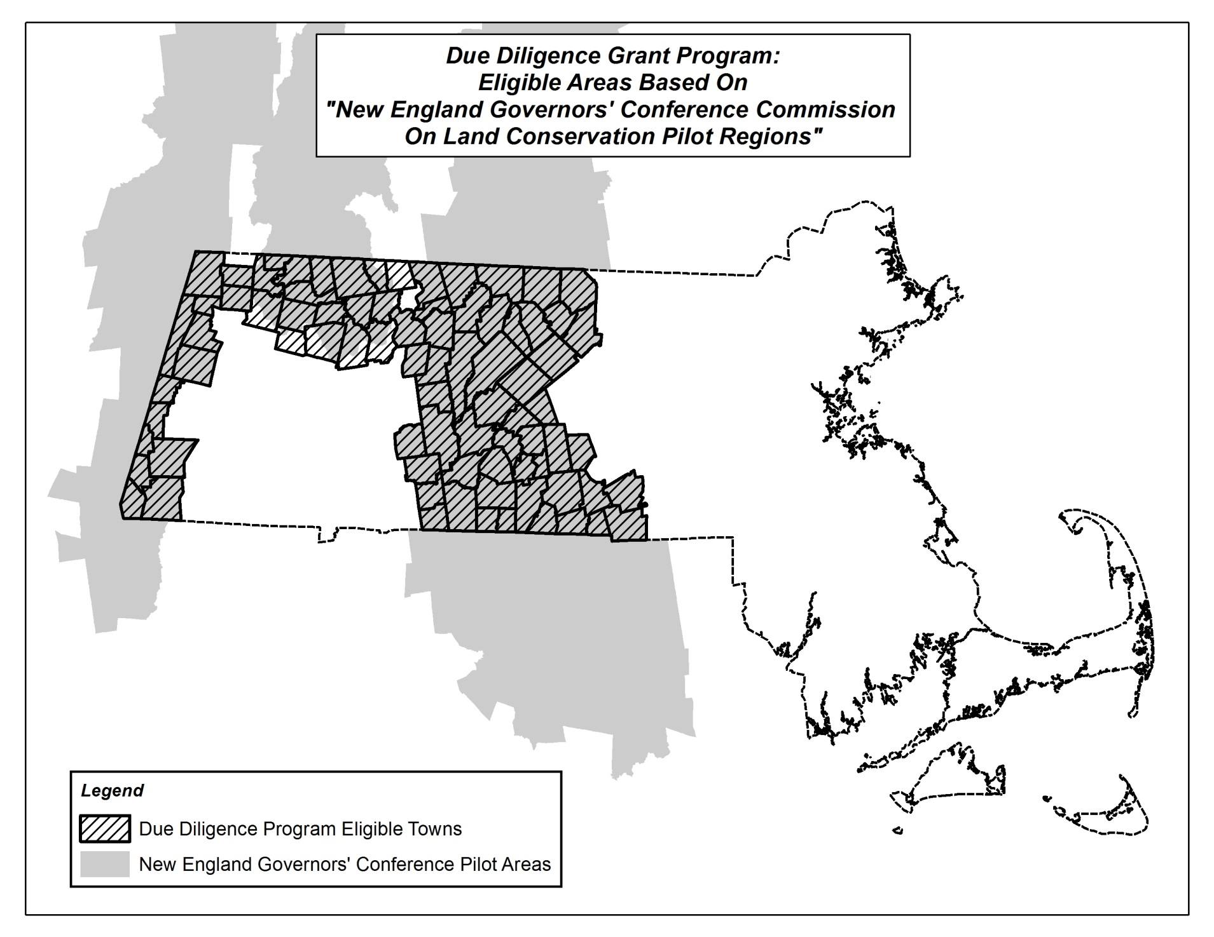

EXHIBIT B – Eligible Municipalities

ADAMS
ALFORD
ASHBURNHAM
ASHFIELD
ATHOL
BARRE
BELCHERTOWN
BERNARDSTON
BRIMFIELD
BROOKFIELD
BUCKLAND
CHARLEMONT
CHARLTON
COLRAIN
CONWAY
DEERFIELD
DOUGLAS
DUDLEY
EAST BROOKFIELD
EGREMONT
ERVING
FLORIDA
GARDNER
GRANBY
GREAT BARRINGTON
GREENFIELD
HAMPDEN

HANCOCK
HARDWICK
HAWLEY
HEATH
HOLLAND
HUBBARDSTON
LANESBOROUGH
LEICESTER
LEVERETT
LEYDEN
LUDLOW
MONROE
MONSON
MONTAGUE
MOUNT WASHINGTON
NEW ASHFORD
NEW BRAINTREE
NEW SALEM
NORTH ADAMS
NORTH BROOKFIELD
NORTHFIELD
OAKHAM
ORANGE
OXFORD
PALMER
PELHAM
PETERSHAM

PHILLIPSTON
PITTSFIELD
PLAINFIELD
RICHMOND
ROWE
ROYALSTON
SAVOY
SHEFFIELD
SHELBURNE
SHUTESBURY
SOUTHBRIDGE
SPENCER
STURBRIDGE
SUTTON
TEMPLETON
WALES
WARE
WARREN
WARWICK
WEBSTER
WENDELL
WEST BROOKFIELD
WEST STOCKBRIDGE
WESTMINSTER
WILBRAHAM
WILLIAMSTOWN
WINCHENDON

